livero hotel
hotel reservation form

FAX  TO | Libero Hotel
Mr. Bae in seok
Tel: +82-51-740-2111 Fax: +82-51-740-2100
E-mail: bis9011@naver.com Home Page: http://www.liberohotel.co.kr

Please confirm the following reservation:
Ms. | Mr. | Last Name: |  |  |  |  | First Name:
Title
Nationality |  |  |  |  | Passport No.
Address
Tel |  |  |  |  | Fax
E-mail
Arrival Date |  |  |  |  | Departure Date
Room Rate  (Discounted rate) |  | ▶ Double | ▶ Twin |  |  |  |  |  | ▶ Semi-Family
 |  | 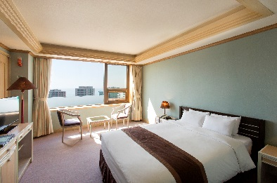 | 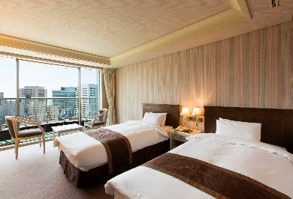 |  |  |  |  |  | 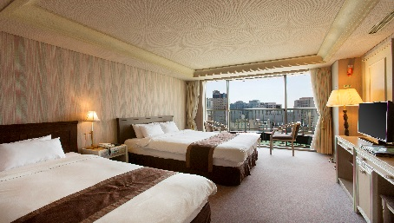
week, Friday : KRW 66,000
Saturday : KRW 99,000
No. of Person for breakfast (per person / meal) KRW 13,200
- The rates above include 10% tax.
- Guest rooms at discounted rates have been reserved for conference participants in the hotel. Please make sure your room reservation should be made by March 18, 2017.
- Original rates will be applied to all room reservation made after March 18, 2017.
Booking Guaranteed
Card Type |  |  |  |  | Name on Card
Card No.
Signature |  |  |  | Exp. Date |  |  |  | ( / / )

Reservation Cut-Off Date:March 18, 2017.

Any cancellations should be made by March 19, 2017, and no-show will be subject to charge for one night.

